House #3

A house of glass
On an island
Using all available lighting
Inhabited by collectors of all types

-Stationary plexiglass roof, on a wooden frame, with modular, moveable (wheeled) plexiglass or plastic sheeting walls. The structure can function as a whole and also be taken apart, turned into screens, stages, etc.

-Positioned on the site between the two trees.

-Emphasizes one’s own agency over transparency

- Allows people to see in but subverts surveillance in different places with one way mirror or plastic

- Encourages interchangeability between indoors and outdoors

- The structure will facilitate collection -- of what and how still being discussed.
Some ideas:
Cameras mounted on the roof to collect images of the sky throughout the day
Sound recordings around the house and of different areas in the Institute to be transmitted into the house
Sound recordings of different institutional bodies and settings (a form of institutional critique): Dean’s meetings, budget meetings, Academic Council, student council, cafeteria, tatum, spaces belonging to different schools (music practice rooms, animation studios, critical studies classes, art crits, theater and dance rehearsals, etc.

Drawing to follow:

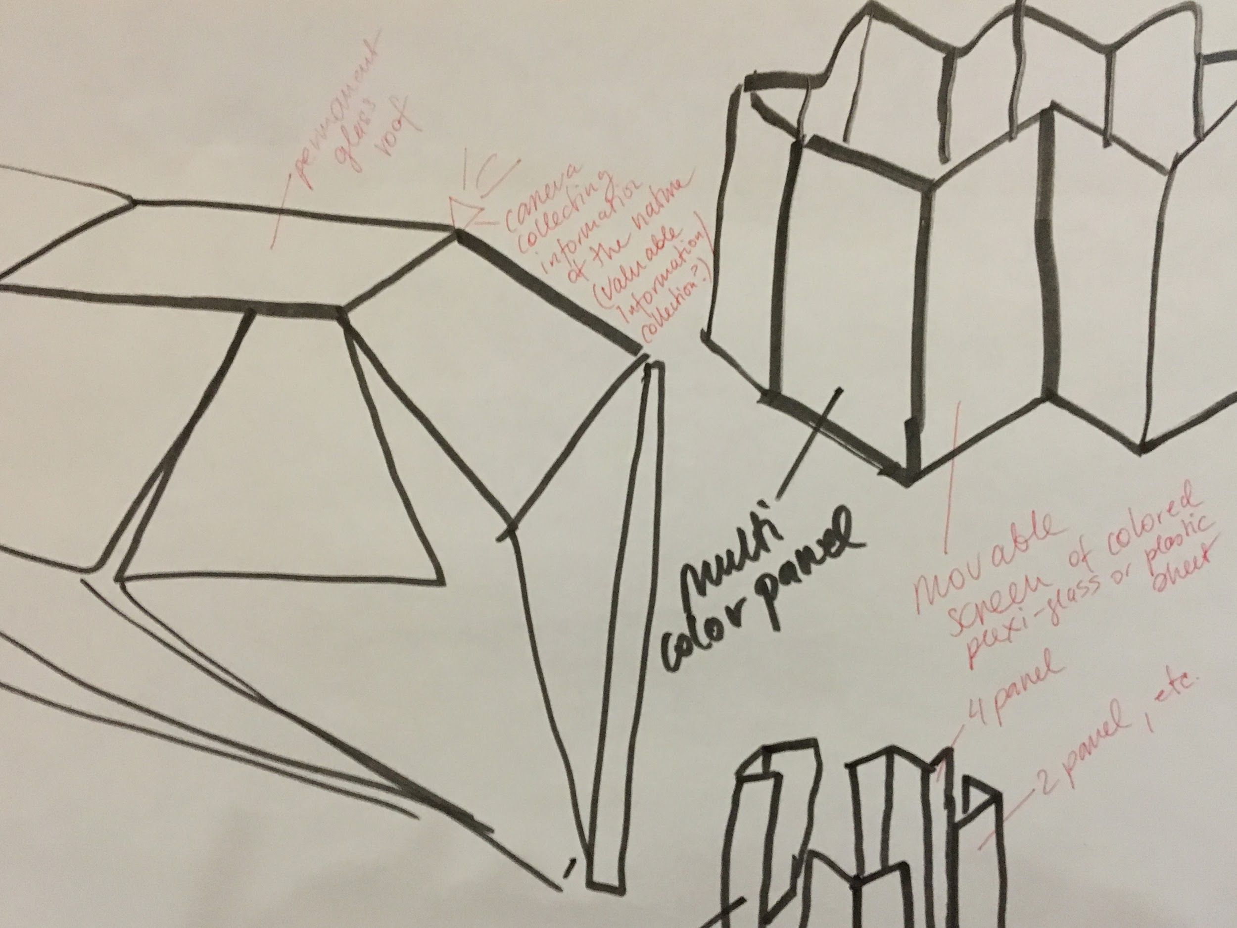
Full-size drawing

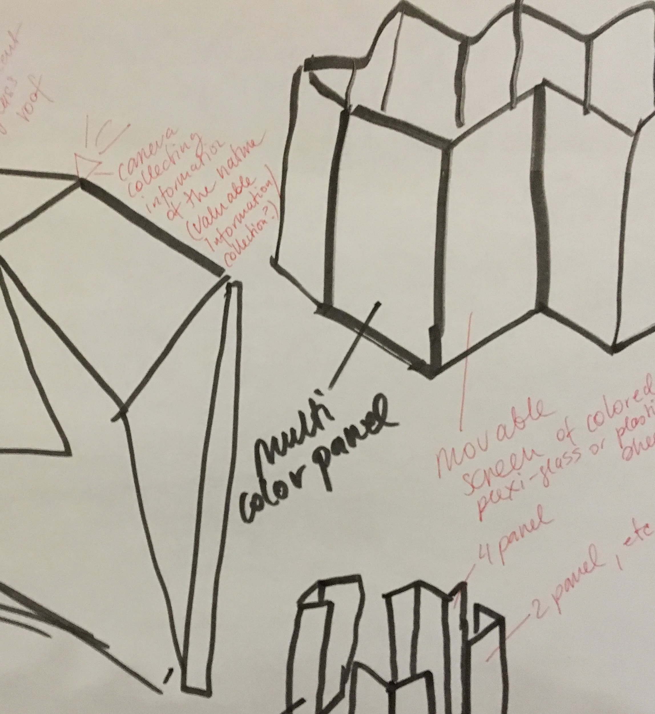

Detail

