House #2

A House of Dust
In a cold windy climate
Using candles
Inhabited by lovers

The house will consist of a series of tunnels or tunnel-like spaces, a refuge from the world that is also a journey. They will evoke movement through the earth -- through the dust -- a warm inside, cold outside.

-Some parts of the tunnels will be open, some closed, so that it isn’t clear where to enter or exit

-There will be cloth material and mirroring inside the tunnel spaces. Mirrors encourage loving (and self-loving) glances, and also gather dust. As the space is activated, dust is created.

-- Some tunnels will encourage sitting/crawling; some will be big enough to stand; some only big enough to let the wind whistle through. Some will dead end.

-- An “acoustic” tunnel should go up to the balcony, so someone on the balcony can listen in to the activities in the house, sound pieces can also be enabled this way.

- A tunnel should go up to the tree

- The “candles” could be evoked by flickering film projected inside the tunnels

- The tunnels can stretch out in different directions, use all of the space available

- At the end of the session the tunnel idea was modified into more of a tent-like structure with posts of different lengths hung with fabric, so that certain areas are high ceilinged, others quite low to the ground. People can move inside in some areas. The areas that are not accessible under are accessible from the outside. People can lay down over the surface of the fabric. We are still deciding between these two concepts.

- What follows is a design + materials option for the tent-like structure, and a design +materials option for the tunnel-like structure

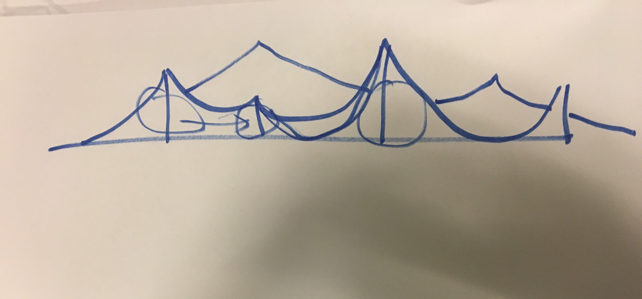
Frontal view

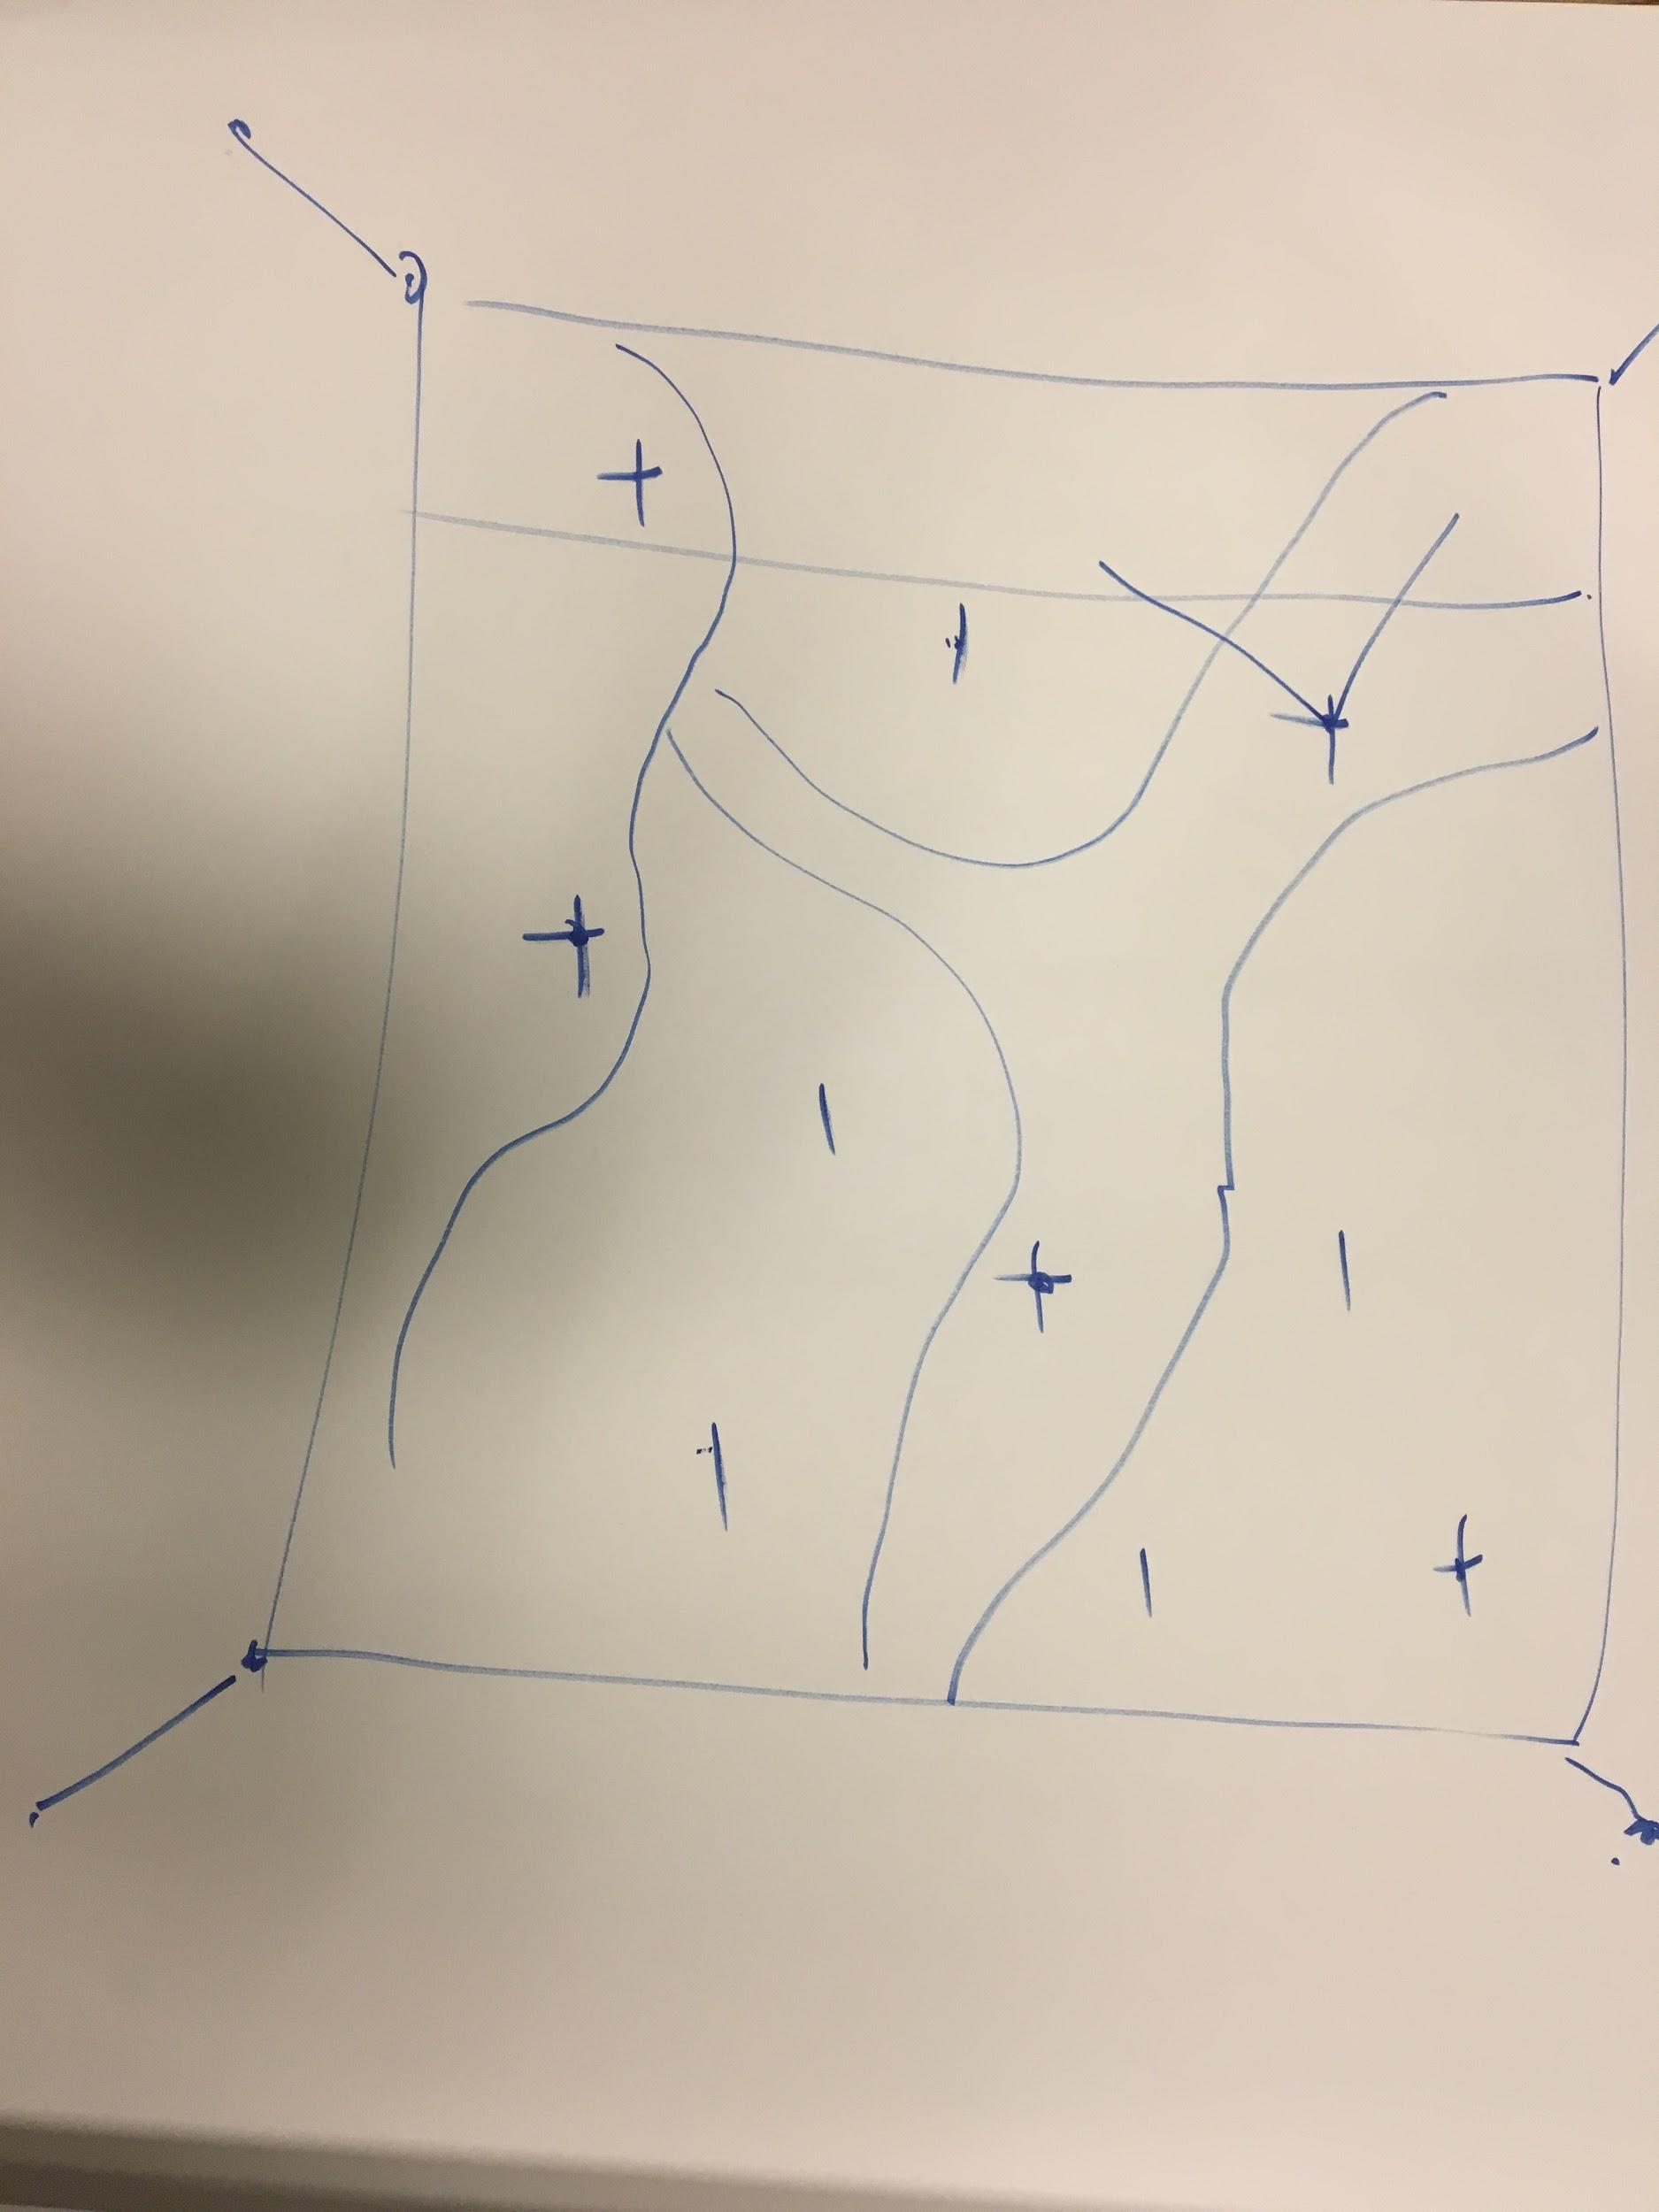
Aerial view
Burlap fabric to drape tentlike structure: http://www.joann.com/burlap-fabric/696237.html?utm_source=google&utm_medium=cpc&utm_campaign=%5BADL%5D%20%5BShopping%5D%20Product%20Type%20-%20Margin%20%5BMobile%5D%20%5BHigh%5D&gclid=EAIaIQobChMI4Kr9n7nR2AIVEtVkCh0VtgZ8EAQYAyABEgJpH_D_BwE

Tunnel Drawing:

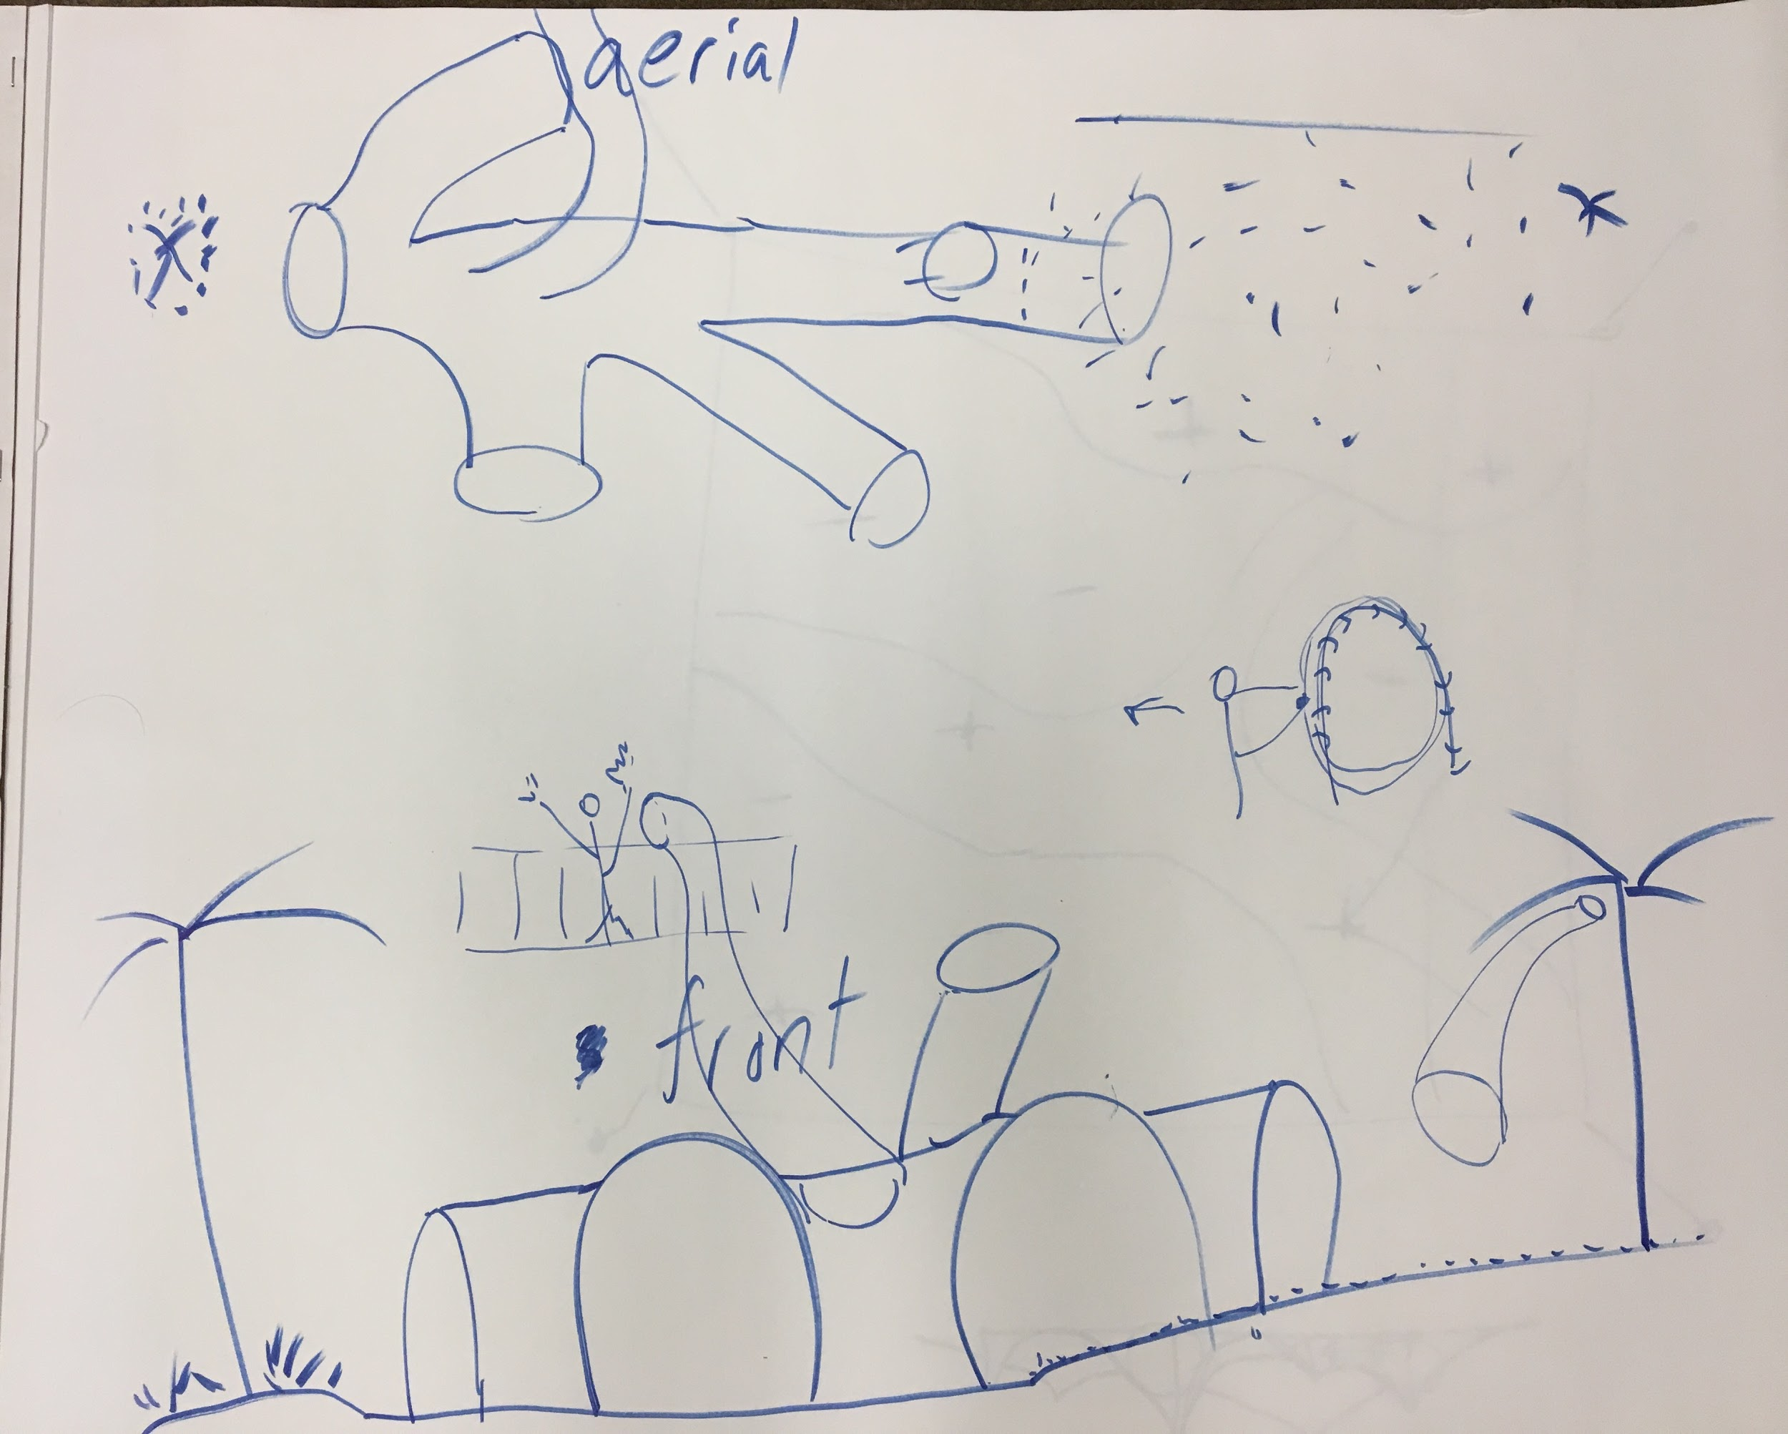
Tunnel materials: metal, plastic armature with a fabric skin, accordion-type
Model: http://hightunnels.org/materials-construction/

